
West Silvertown Foundation
Job description

Job Title: Assistant Youth Worker (Intern)
Location: Britannia Village Hall, 65 Evelyn Road E16 1TU (as well as local community venues)
Accountable to: Youth Services Manager
Number of Hours: Full Time, 5 days, 36.25 hours per week (some evenings and weekends/TOIL will be given)
Pay: £27,898pa (£14.80 per hour)
Duration: 12 months fixed term contract, with potential for extension based on funding/performance.

Main purpose of Job:
To work as part of the Youth team to deliver a variety of youth activities and mentoring which aims to empower young people to feel connected to their community and live to their full potential. You’ll deliver these high-quality youth sessions in Britannia Village Hall, Oasis Academy Silvertown, and across the community, ensuring young people are safe and positively engaged with their community. The role offers hands-on training, supervision, and professional development opportunities within a supportive team.

Duties and Responsibilities:
- To work as part of the Youth team, to assist the delivery of safe, engaging and inclusive youth activities (sports, arts, creative, and social action).
- To work directly with and alongside young people to empower them to overcome multiple levels of deprivation, counter social exclusion and help them to realise their potential. This will be conducted through open access youth sessions as well as one-to-one and group mentoring sessions.
- To set up and clear away before and after activities.
- To attend and participate effectively in team meetings, supervision and appraisal meetings.
- To complete day-to-day administrative tasks alongside the Youth Services Manager, such as developing youth activities and planning trips.
- To fully participate in the Jack Petchey Internship Programme, including attending an introductory residential and development workshops and receiving ongoing mentoring.
- To support the effective implementation of safeguarding policies and procedures within WSF. Helping to maintain a safe, welcoming and respectful environment.
- To be familiar with and comply with WSF’s Health and Safety Policy. In the event of any immediate danger to take appropriate action to reduce the risk of physical danger to either project users, volunteers or staff and to bring these to the notice of senior staff.
- To support the Youth team in keeping records of attendance in all project activities, gathering and storing evidence, and other tasks as necessary.

Person Specification:
Essential
- A passion to empathise with young people’s situations, be committed to inclusion and build positive, trusting relationships. Using these values, you’ll have the drive to enable a positive trajectory of their personal development.
- Enthusiastic about personal development with a flexible attitude toward new tasks and opportunities.
- A strong commitment to keeping an inclusive mindset, with the ability to work with diverse groups.
- Strong communication and interpersonal skills.
- Flexible and adaptable, able to work evenings and weekends.
- Good time keeping and the ability to meet deadlines for administritive tasks.
- Ability to build professional relationships.

Desirable
- Have demonstrated an interest in taking a proactive and committed approach to working with young people.
- Understanding of the challenges facing the young people of West Silvertown, such as social exclusion or deprivation.
- Ability to understand and implement safeguarding and health and safety policies to keep young people safe..
- Someone with lived experience of the community, or kinds of community, we serve.

This Job Description is not prescriptive; it outlines the key tasks of the post-holder and is subject to change in consultation with the post-holder.

About the Jack Petchey Internship Programme
As part of this role, the successful candidate will be part of the Jack Petchey Internship Programme with 18 other interns from different youth organisations in London and Essex. This development programme will involve attending a residential launch conference, four professional development workshops through the year and a celebration event at the end of the programme. The successful candidate will receive an extra training bursary of £1,000 for approved training and will be matched with a mentor from another organisation to help support their professional development. The Jack Petchey Internship Programme training days and events will take place in person in London, and the successful candidate will be expected to take full part in this programme alongside their role at BV Youth.

Closing date: Monday 2nd February

Proposed interview dates: w/c Monday 9th February

Planned start date: From 2nd March, candidates must be available to start by Monday 23rd March.
References / Enhanced DBS required.

Funded by
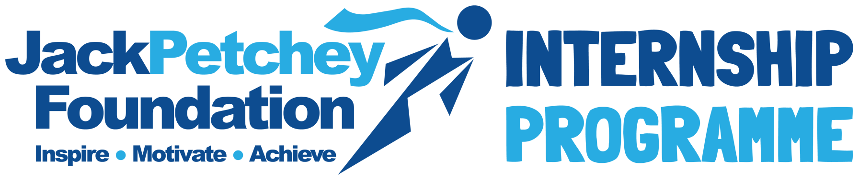
https://www.jackpetcheyfoundation.org.uk/opportunities/internships/

